EPRA BPR Awards Updated Scoring Methodology - FAQ

*- Details as of September 2024 -*

1. Why has the BPR Awards scoring methodology changed?

The purpose of revising the EPRA BPR Scoring Methodology is to make it clearer and simpler. For example, we renamed the “Core Recommendations” to “Performance Measures” as it was the case for the other BPRs (EPRA Earnings, NAVs, NIYs, Vacancy Rate, Cost Ratios and LTV). The Core Recommendations that were part of the scoring included: the like-for-like rental growth disclosures and the EPRA CapEx table. Also, we have decided to remove the zero-line items from any BPR tables, please refer to Q.4. The scoring allocation has slightly change making the total up to 100. And finally, the EPRA LTV has been included as part of the other BPRs.

1. When will the new BPR Awards methodology become effective?

The updated methodology will be applied for the first time during the 2025 BPR Awards assessment, where the annual reports with a fiscal year-end between April 30, 2024 and March 31, 2025 inclusive will be reviewed. The list of participating companies will be determined based on EPRA’s membership as of March 31, 2025.

Exception will be made for companies with year-ends between April 30, 2024 and the release of the updated EPRA BPR Guidelines (September 30, 2024). These companies will then still be assessed under the previous methodology.

1. Will the assessment change under the updated methodology?

No, the assessment remains the same. EPRA’s BPR Guidelines include specific additional disclosures for real estate companies, while the survey’s questionnaire contains around 100 questions connected to non-gaap financial reporting. Several of those questions are not scored and used only for statistical purposes. The following EPRA BPR disclosure elements will be scored.1

* + General Recommendations: review the language of financial reporting and general compliance with the EPRA BPR summary tables’ disclosure.
  + EPRA Performance Measures (PMs), detailed assessment of the EPRA Earnings, NAVs, NIYs, Vacancy Rate, Cost Ratios, LTV, like-for-like rental growth and capital expenditure disclosure.

1. With regards to the zero-scoring policy, does it include the EPRA Earnings per share?

Correct. For the EPRA Earnings per share, the calculation has to be disclosed otherwise no point will be granted. In this case, it means that the number of shares to go from the EPRA Earnings to the ERA Earnings per share has to be disclosed.

1 For more information on the exact scoring criteria and points’ allocation, see questions 6 and 7 (pages 4-7 of this FAQ).

1. What is a zero-line items and why should we remove them?

A zero-line item refers to any adjustment in any of the BPR tables that is non-applicable and therefore corresponds to 0. For example, while computing the EPRA LTV, if your company does not have any commercial paper, foreign currency derivatives, hybrids or owner-occupied property, therefore you can directly remove these lines from the table rather than disclosing them with a 0 next to them. That way the table will only include the adjustments applicable to your company and will make the EPRA disclosures as a whole more concise and clear. Companies will only be allowed to remove the zero-line items if they respect the following condition: companies should provide an undertaking below the BPR table that the adjustments not disclosed have a zero value.

1. What will be the total points’ allocation for each recommendation under the new methodology?

For the purposes of the survey, the following allocation of points will be applied:

1. Was there any change to the awards category?

Yes, only to the Silver Award Category. Before to get a Silver Award, a company needed to comply with the BPR guidelines so that a minimum of 3 different BPRs had to be disclosed in their annual report. Now, a company has to report a minimum of 5 BPRs, which strengthen the compliance overall. To receive a Silver award, a company also has to score a minimum of 60% which remains the same with the updated version.

1. What will be the scoring procedure for Performance Measures for which there is one variation?

For Performance Measures for which there is only one variation, such as EPRA Earnings/EPS or Vacancy Rate, the following scoring procedure will be followed to determine full or zero compliance.

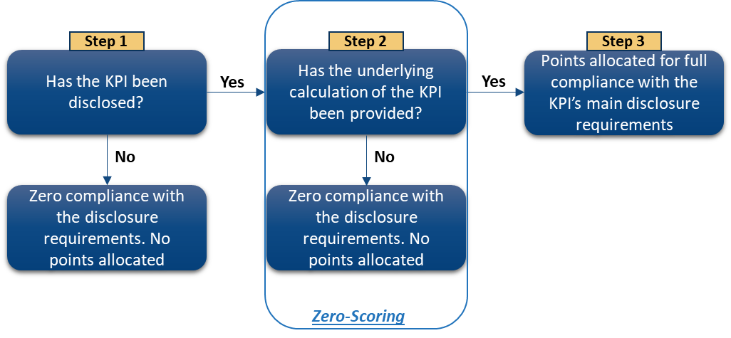

Example 1: If the company has disclosed both EPRA Earnings/EPS (step 1) and the respective underlying calculations (step 2- reconciliation to IFRS Net Income), then all points would be allocated (step 3) since full compliance with the KPI’s main disclosure requirements has been observed.

Example 2: If the company has not disclosed EPRA Earnings/EPS (step 1), then no points would be allocated since, for the purposes of the survey, this would translate into zero compliance with the KPI’s disclosure requirements, meaning that the KPI’s score will be zero.

Example 3: If the company has disclosed EPRA Earnings/EPS (step 1), but has not disclosed the respective underlying calculations (step 2 – reconciliation to IFRS Net Income), then the zero-scoring policy would be applied (step 2) and no points would be allocated, meaning the KPI’s score will be zero.

Example 4: The same rationale will apply for the EPRA Vacancy rate. Full compliance with the main requirements will be observed if Vacancy Rate and its underlying calculation (ERV vacant space/whole portfolio) have been disclosed. If any of those conditions are not met, then the score will become zero.

1. What will be the scoring procedure for Performance Measures for which there are many variations?

For Performance Measures for which there are several variations, such as the three EPRA NAV metrics (NRV, NTA, NDV), the two Net Initial Yields (NIY & topped-up NIY), and the two Cost Ratios (including direct vacancy costs and excluding direct vacancy costs), the following scoring procedure will be followed to determine full or zero compliance with the KPI’s primary disclosure requirements.

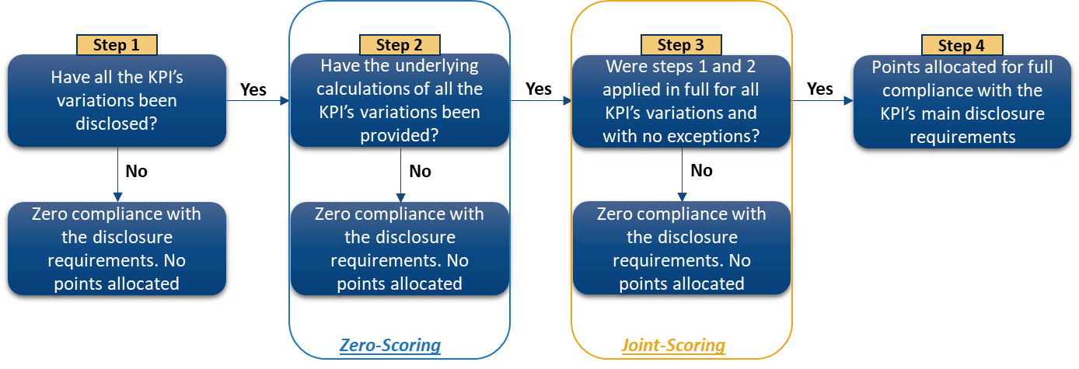

Example 1: If the company has disclosed all three variations of the new EPRA NAV metrics (step 1 - NRV, NTA, NDV) and the respective underlying calculations for each variation (step 2- reconciliation to IFRS Equity attributable to shareholders), then points would be allocated only if the two previous steps have been applied in full and with no exceptions for all the three KPI’s variations (step 3 – joint scoring), ensuring full compliance with the KPI’s main disclosure requirements (step 4).

Example 2: If the company has not disclosed all three variations of the new EPRA NAV metrics (step 1

- NRV, NTA, NDV), then no points would be allocated as, for the survey's purposes, this would translate in zero compliance with the KPI’s disclosure requirements, meaning that the KPI’s score will be zero.

Example 3: If the company has disclosed all three variations of the new EPRA NAV metrics (step 1 - NRV, NTA, NDV), but has not disclosed the underlying calculations for all three variations, then the zero-scoring policy would be initially applied (step 2). In addition, under the joint-scoring policy (step 3), the KPI’s combined score will become zero and no points would be allocated, since, for the survey’s purposes, if partial or no compliance is demonstrated, then this would translate into zero compliance.

For instance, if a company has reported all three NAV metrics (NRV, NTA, NDV), but has disclosed the underlying calculations only for NRV and NTA (but not for NDV), then under the zero and joint-scoring policies (where partial compliance with a KPI’s main disclosure requirements is not allowed), the KPI will be deemed as not disclosed and its combined score will be zero (i.e. zero pts for all 3 variations).

Example 4: The same rationale will apply for the two EPRA Net Initial Yields and the two EPRA Cost Ratios. Full compliance with the KPI’s main disclosure requirements will be noted only if the company:

1. Has disclosed all variations of the KPIs - i.e. a) both NIY and topped-up NIY; and

b) both CR including direct vacancy costs and CR excluding direct vacancy costs

1. Has disclosed the underlying calculation for each KPI’s variation (points a and b above) and with no exceptions (i.e. no partial compliance with the requirements will be permitted)
2. If any of the above conditions is not met, then zero/joint-scoring policy applies - i.e. zero pts.